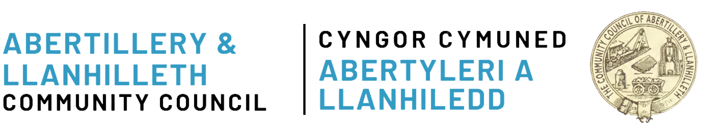
Town in Bloom – Community Tubs
Application Form

Please specify which tubs you would like to look after:

Tub Numbers
If the numbers are missing/unknown, please specify the locations
If possible, provide the what3words
If you would like new tubs to be installed, please specify how many and the proposed locations
If possible, provide the what3words

Name of Applicant
Organisation Type
Please leave blank if you are an individual applicant
Contact email address

Contact telephone number

The maximum amount of funding is £75 per tub, per year. Applicants must re-apply each year if they wish to continue maintaining their tubs. Valid receipts must be submitted to claim this funding.

Signed
Date

To submit your application:
Email: clerk@abertilleryandllanhilleth-wcc.gov.uk
Post: The Clerk, Abertillery and Llanhilleth Community Council, Mitre Street, Abertillery, NP13 1AE

